CO4219/CO7219 Internet and Cloud Computing
Cloud System Design and Evaluation
Name: Chitra Varadarajan Kumar
Username: cvk2
Group No: 35

Task 1: Produce a Design of your Private Cloud
The aim here is to host a White board application in a private cloud set up, run it on at least three servers(nodes) on three different virtual machines inside the Virtual Private Network. On the client side, the whiteboard application belongs to three different group of users.
The DNS server keeps track of application server availability where the control pane distributes the traffic over multiple server instances.
Architecture:
Our application here is 3-tier one, where there is a separation of logical and physical layers. The following are the tiers used in our architecture:
- White Board Client App- This is the presentation tier where the user interaction takes place. The content can be static or dynamic.
- White Board App Server- This tier queries the database for the information regarding the client states and other logical information.
- Database- The tier, which is the backend of our application, we use MongoDB which is a document database providing scalability and flexibility via querying and indexing.
The Design:
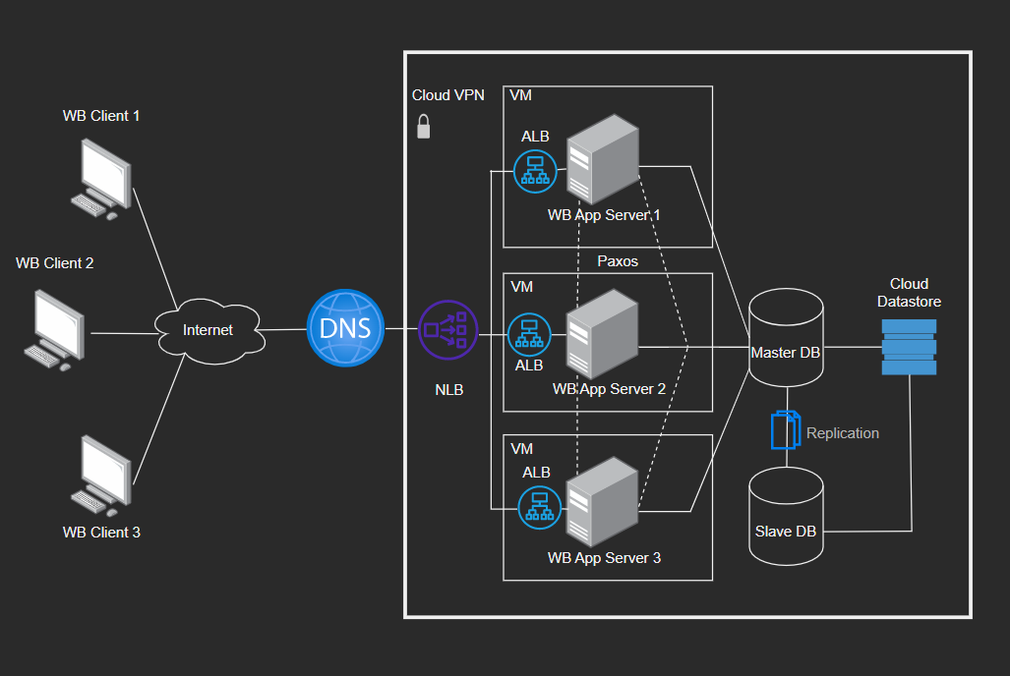
The Virtual Private Cloud(VPC):
In a public cloud setting, a virtual private cloud provides a flexible on-demand pool of shared resources that offers some level of separation between the many businesses employing the resources.
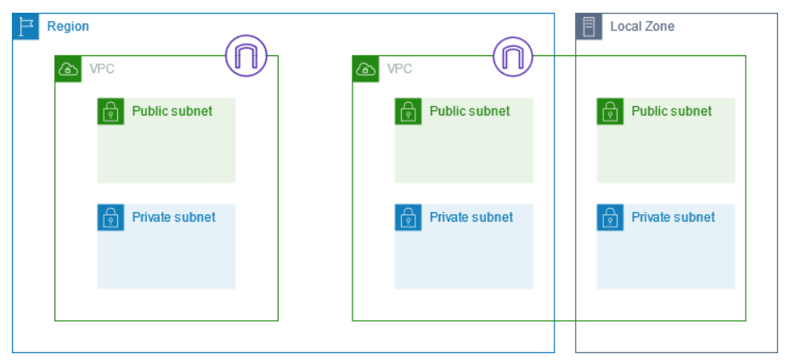
Image Reference: https://docs.aws.amazon.com/vpc/latest/userguide/configure-subnets.html
In this virtual private cloud, I have public and private subnets that are a range of IP addresses I can use for our White Board(WB) app server. The instances in public subnets can directly connect to the internet but the instances in private subnets need a Network Address Translation Gateway to use the services outside the VPC.
Scalability:
The main advantage of using load balancer in our design is to achieve scalability by distributing inbound flows to backend pool instances by the load balancer from the load balancer's front end.
Apart from the Network Load Balancer(NLB) at the front end , where private IPs are required solely for the frontend, an internal Application Load Balancer(ALB) is also employed.
The algorithm used for the load balancing is Equiload balancing where according to the size of the request, the traffic is routed to the servers. Apart from this, we also do a region-based routing if traffic where if one region is down, the next closest healthiest region is chosen.
Consistency:
Data consistency is achieved at various levels by using NoSQL document-based database data replication. This helps us reach the consistent sate across all the client White Board replicas.
As the requirement here is write heavy across the client applications, Master-Slave replication is used. The master logs all the data updates to the slaves as replicas asynchronously using messaging queues decouple heavy processing workloads.
Network Topology:
The different server nodes in the design use the star topology as it is easier to scale, and every node communicates with every other node in the topology. The consensus between the nodes is reached between the nodes through a group of protocols known as the Paxos. This is highly reliable and durable, in an environment where there is fallible and unreliable set of servers trying to reach an agreement among themselves.
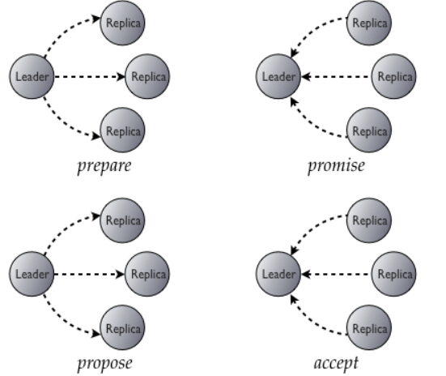
Image Reference: https://www.datastax.com/blog/lightweight-transactions-cassandra-20
Paxos chooses a particular value from among the suggested values and broadcasts it to all the participating computers. After the Paxos method has completed, the suggested value is accepted by all the nodes .

Task 2: Implement the Private Cloud
Cloud Service Provider:
To implement our private cloud, we are using Amazon Web Services, one of the worlds leading providers. Implementing Platform as a Service(PaaS) is helping us to achieve the management of resources for our White Board application on the cloud. Apart from that capacity, software maintenance and deployment are also achieved.
Creating an Instance:
Amazons EC2 instance is a virtual server that runs applications on (AWS) architecture. It enables us to run White board application in the computing environment and functions as a virtually infinite number of virtual machines (VMs).
New servers can be instantly created. Each AMI has a distinct ID of its own. You must first find the instance's ID to launch it on the EC2 cloud.

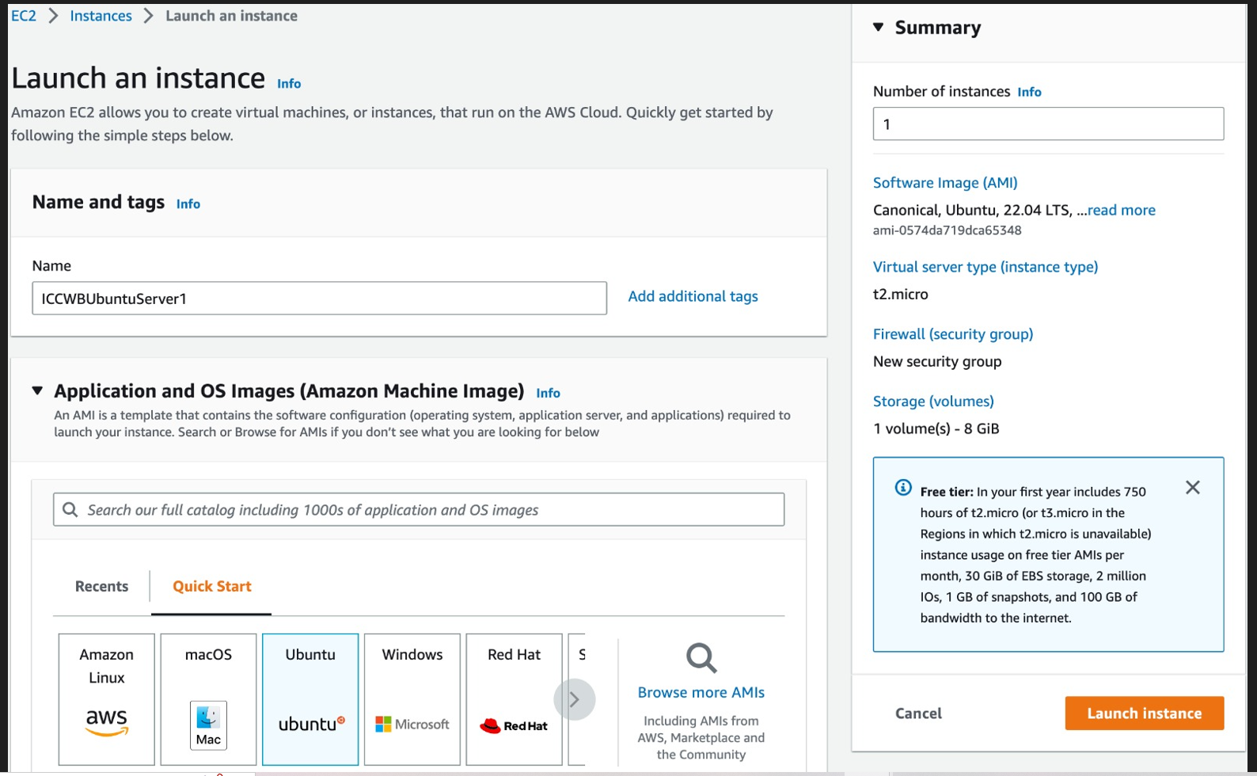
The next step is to provide a key pair value which is an encryption that consists of a public key for data encryption and a private key for data decryption. Choosing the subnets which has the information regarding VPC ID and availability zones for our instances.

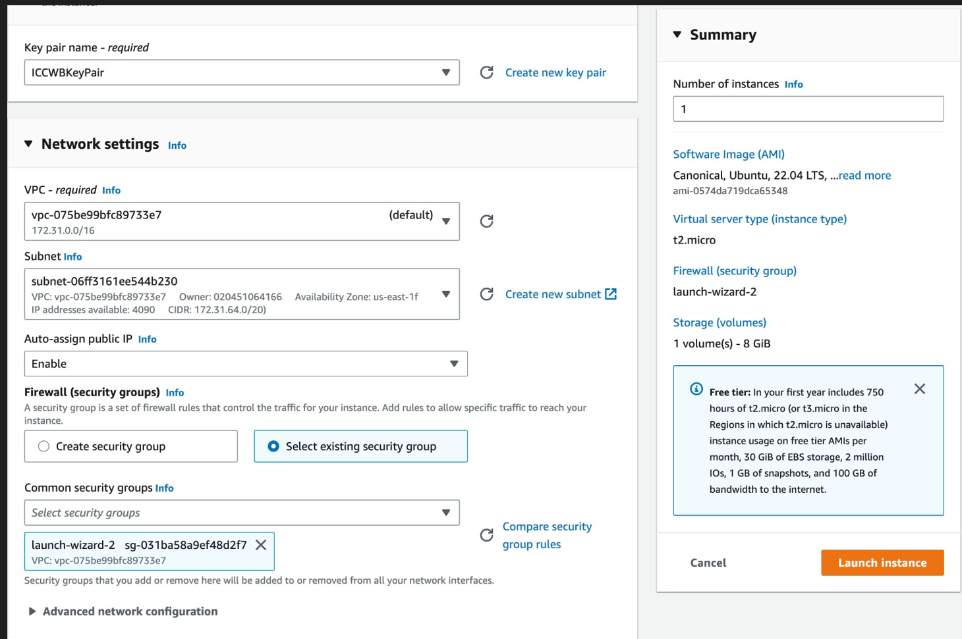

The final instances created can be seen bellow on the EC2 dashboard for our whiteboard application.
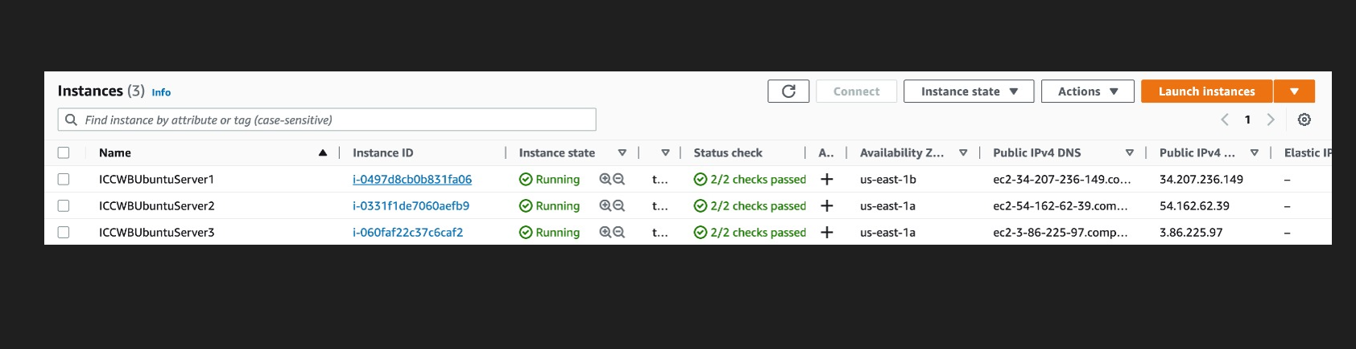

The details about white board server instance 1 can be seen below:
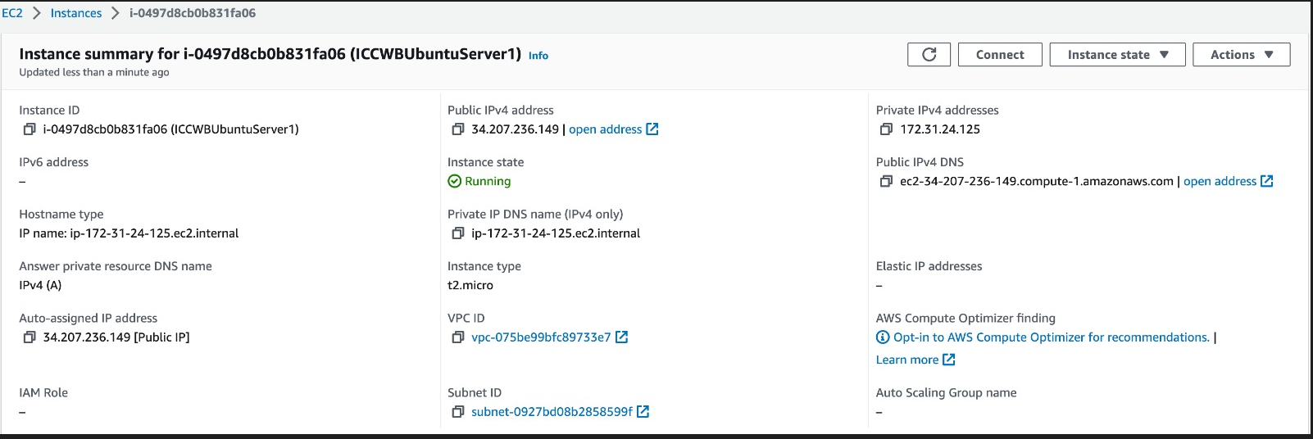

The security details provide the ports used for the above instance that is created:
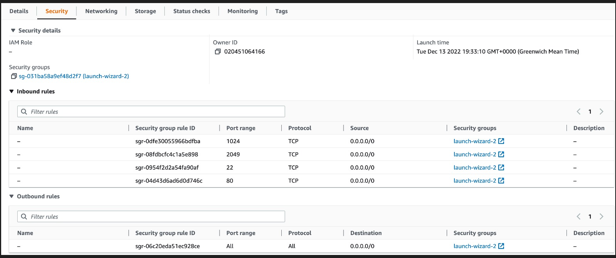

The details of the Virtual Private cloud where all the public and private subnets reside are seen below. The EC2 instances connect to the IP addresses of public and private. There is default VPC provided by the AWS and also custom VPCs.
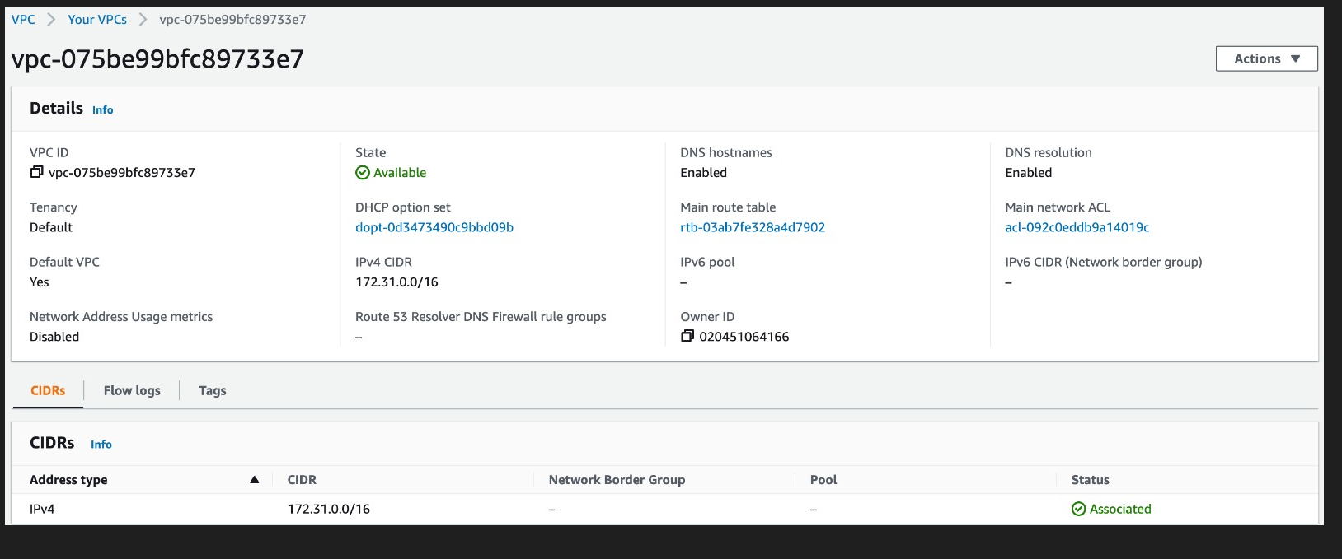
The security group provides the rules for setting up the firewalls allowing specific traffic for the instances.

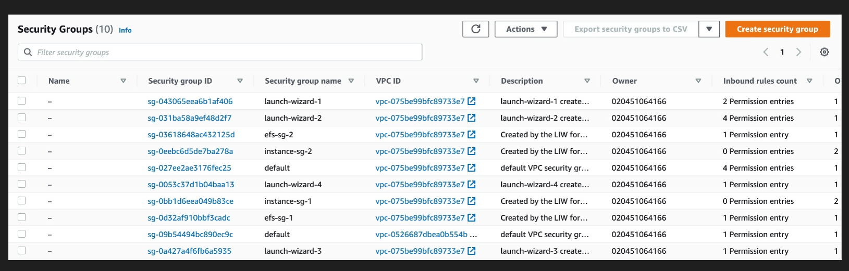
Availability & Fault Tolerance:
Whenever the EC2 Instance is unavailable due to the underlying failures related to hardware, the AWS provides the EC2 Instance Auto recover feature. The feature also provides fault tolerance through Auto Scaling groups where bad instances are terminated automatically and replaced with healthy ones.
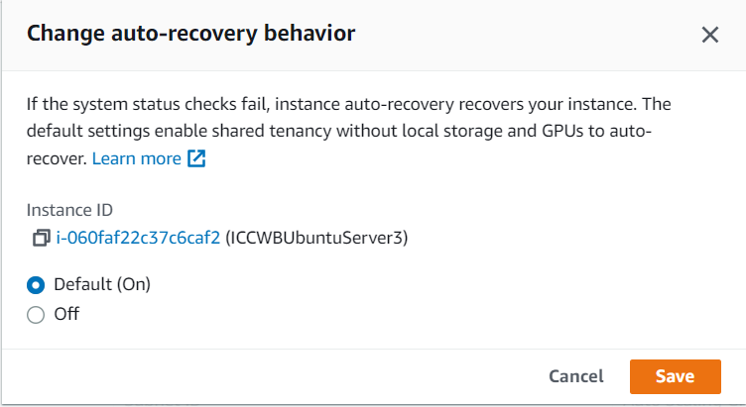

Scalability:
The load balancer here assigns the traffic according to the availability zones in each region. If one of the servers in a region is not available, the load balancer redirects to the next healthy region availability zone.
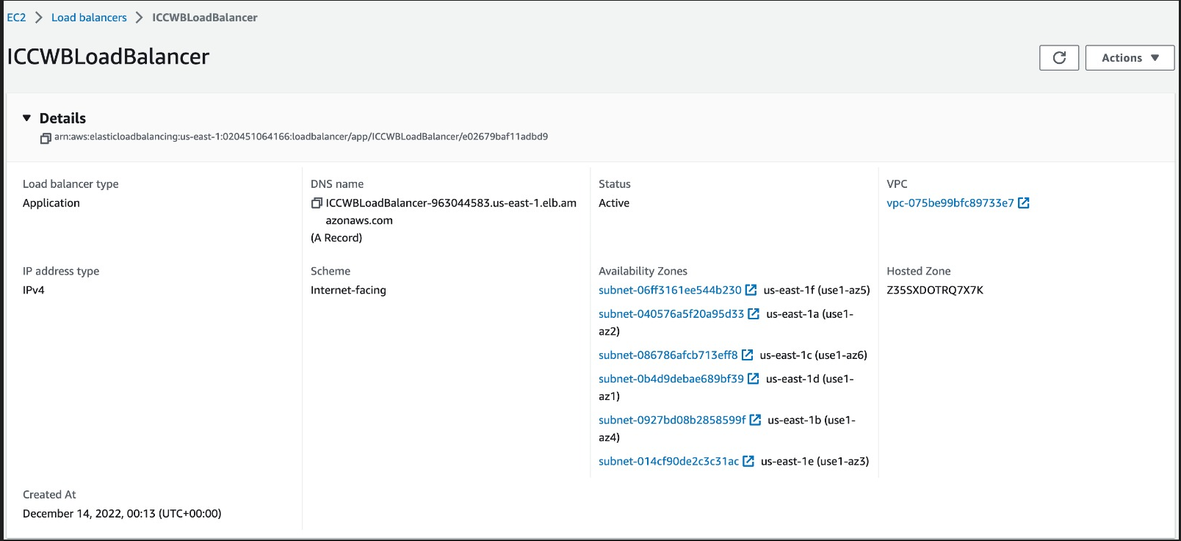
The target groups help the load balancer where to redirect the traffic to the EC2 Instances which have the listeners to listen to the incoming traffic from the load balancers.
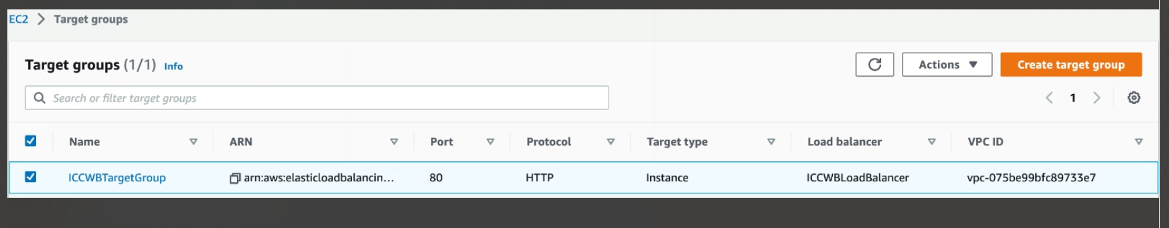

Consistency:
When the client interacts with the White Board application all the states are stored inside the MongoDB database inside the collection as documents. The states are all accessed by the servers inside the EC2 instances, and these states are consistently reciprocated to all other clients connected to a particular server instance.

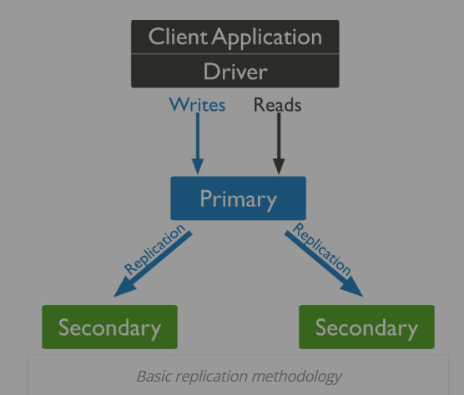
Image Reference: https://www.bmc.com/blogs/mongodb-replication/#:~:text=What%20is%20MongoDB%20Replication%3F,pertain%20to%20any%20mongod%20process.

MongoDB creates a copy of the datasets known as replica sets inside the MongoDB Atlas that is shown below:
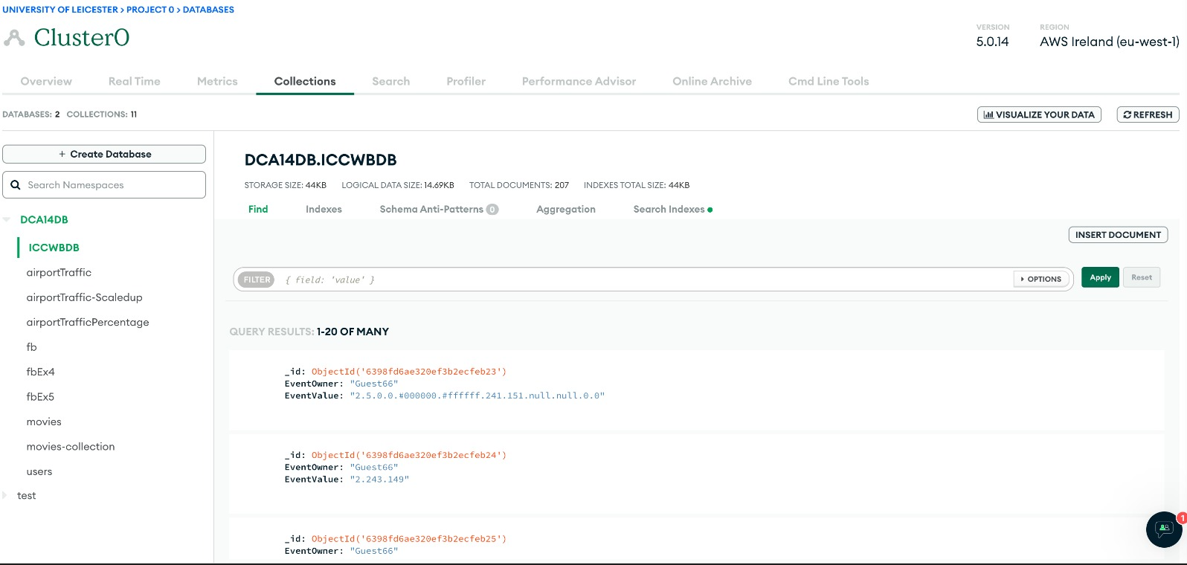
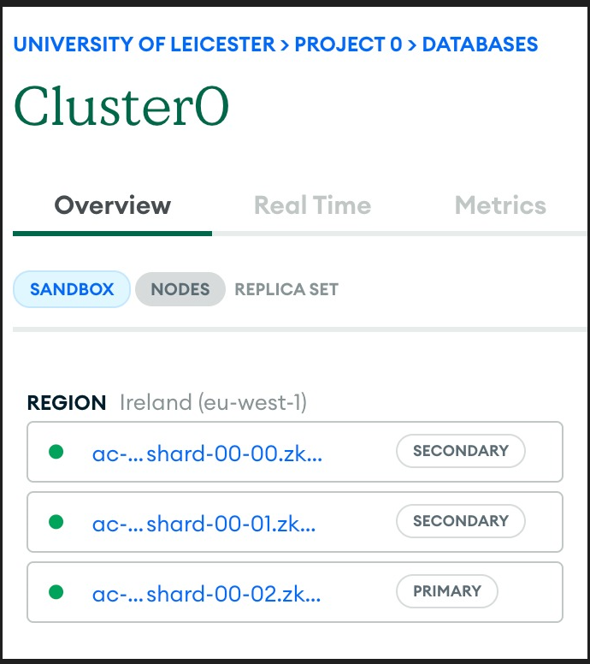
Network Topology:
A variation of the Paxos consensus algorithm is used on the server-side java application where the server nodes can record and communicate the states of the client on White Board application and these states are consistently displayed on the client-side WB app. This is reflected below in our database interaction with the server.
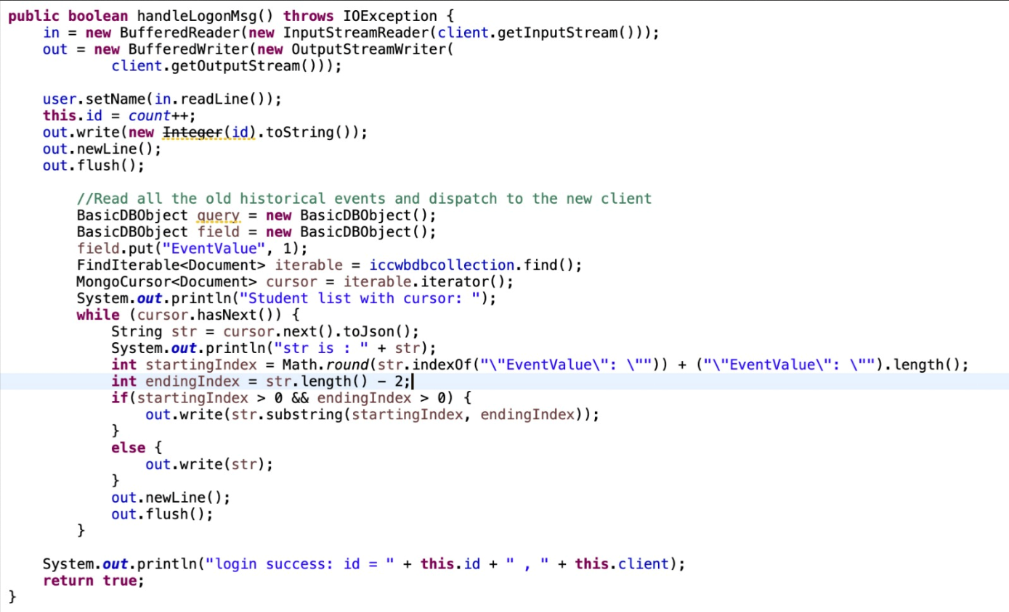

Commands for Deployment:
After launching an EC2 Instance, from the terminal of the local machine a connection I first developed to the virtual machine Ubuntu provided by the Amazon Machine Image(AMI) on the cloud provider. A .pem file is generated of the whiteboard board application server which points to the IP address of the EC2 Instance. The below commend helps to achieve this purpose:
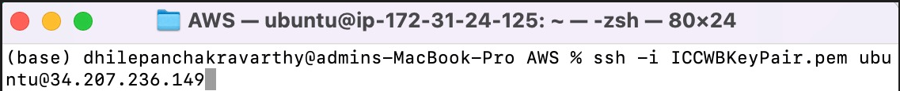

As we can see below the connection is developed with the virtual machine Ubuntu.
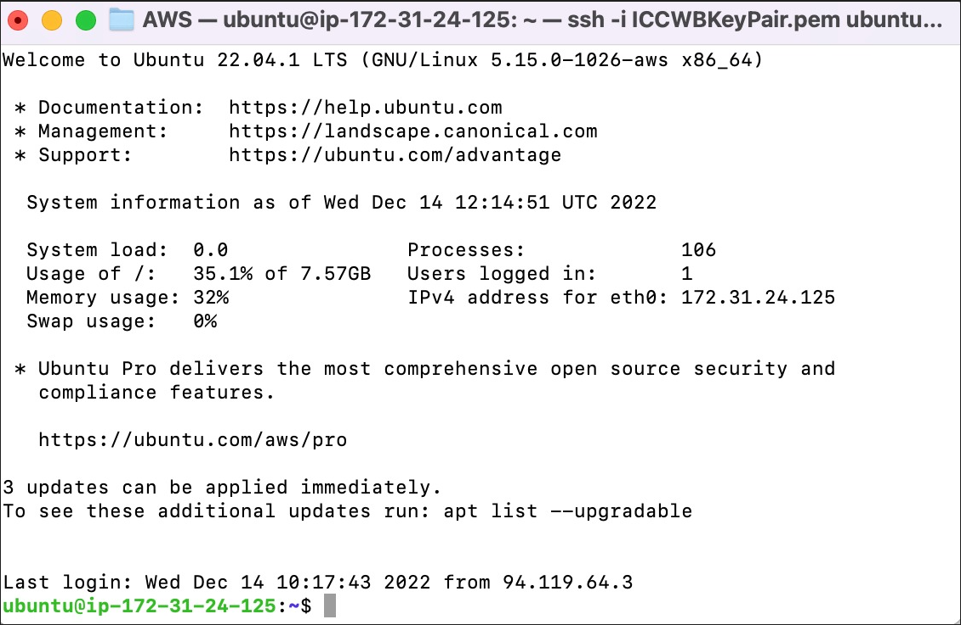
Once the connection is developed with the EC2 instance through the IP address, the white board application server jar file is run inside the EC2 instance. The command below achieves the purpose:
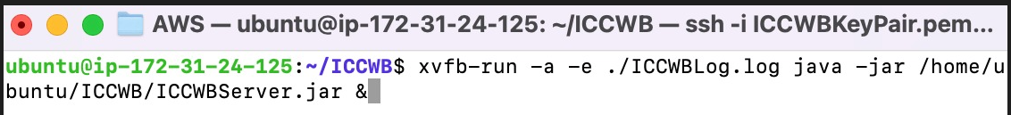
We are using the grep command to look for the java command, which will be present in the output if it is a java process.
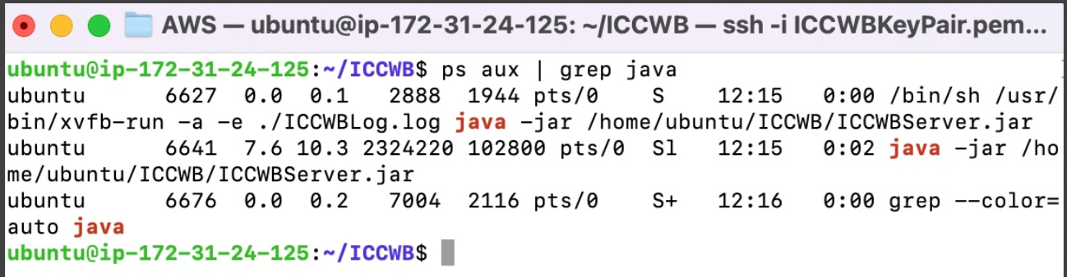
The above pic shows that the whiteboard application server is running inside the EC2 instance.

Task 3: Development of a Distributed Whiteboard Application
The Whiteboard is an interactive application where several clients collaborate with each other in real time. The client-server communication is taking place with the help of web sockets. There are several components we make use of in socket programming for our white board app.
We use process, which is a single instance of executable that is being run by one or more threads. The same process executed concurrently by several threads. A port is used by processes to network with each other in the application. The socket forms by the combination of port and IP addresses where the client and server can be identified.
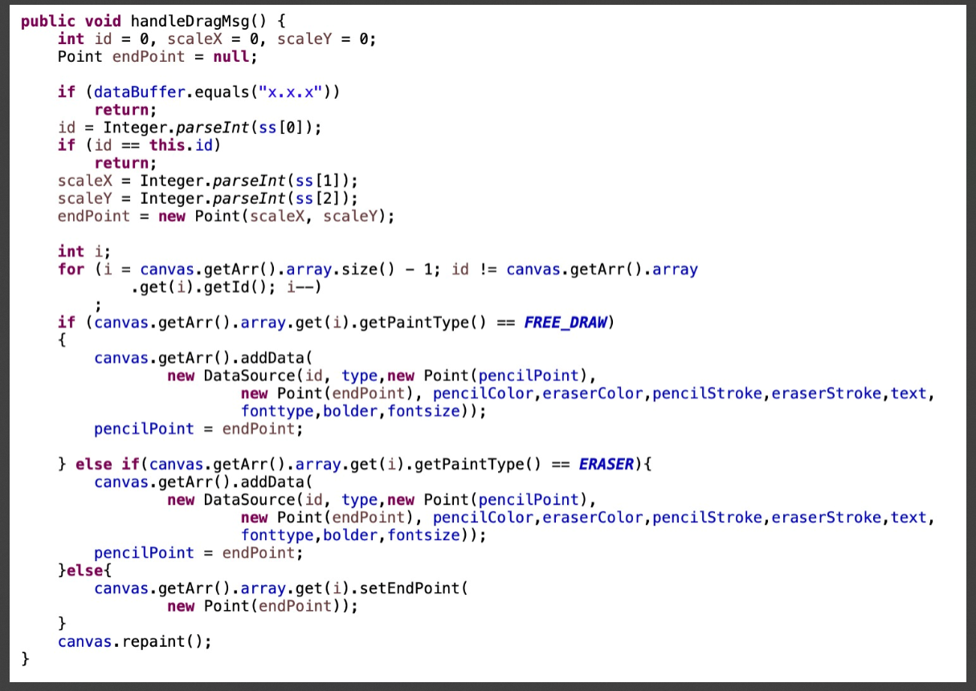
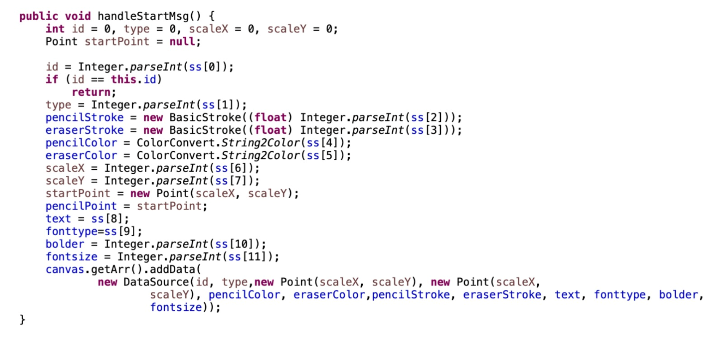
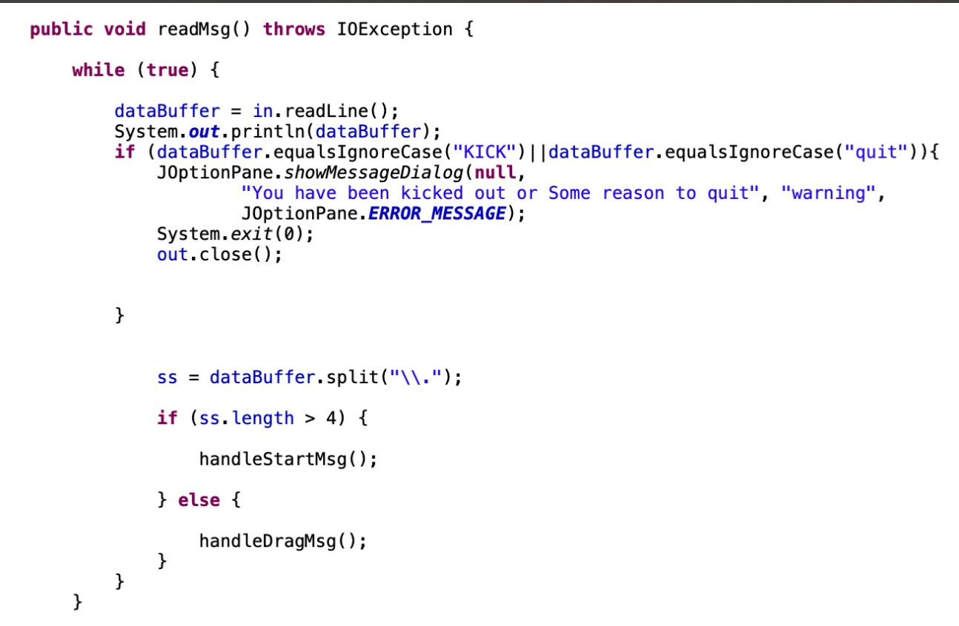

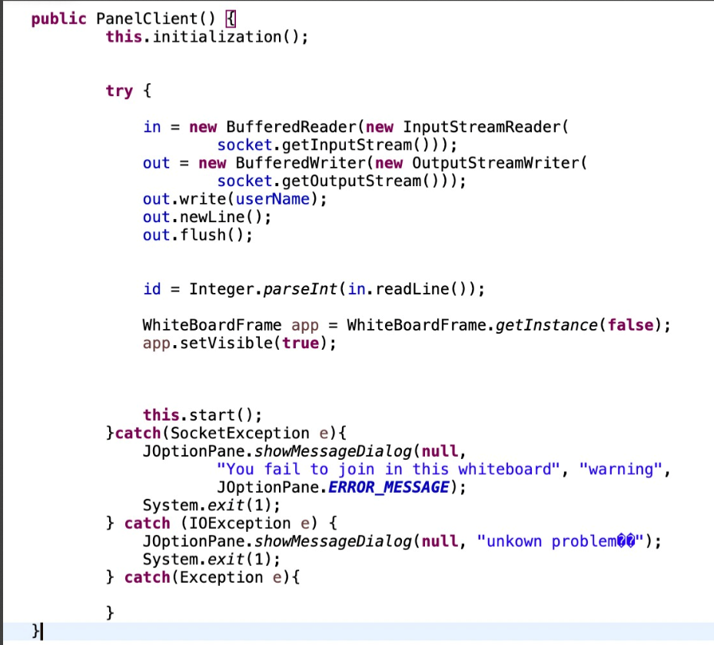

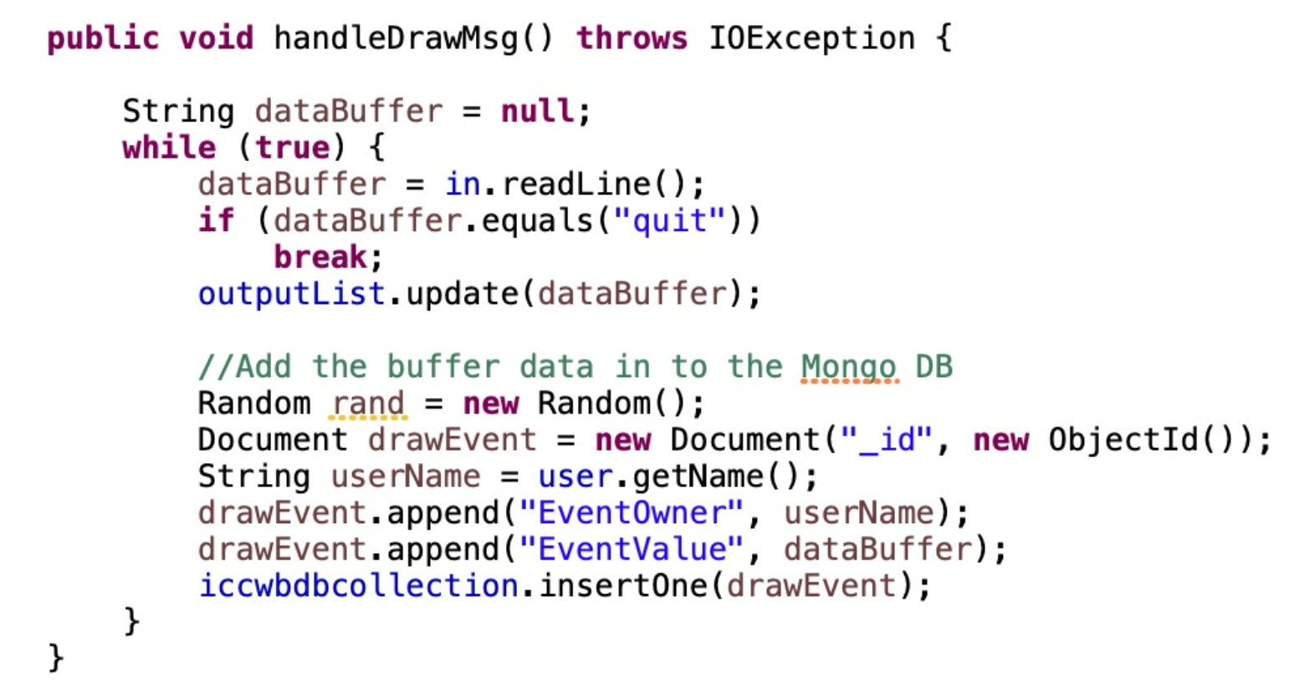
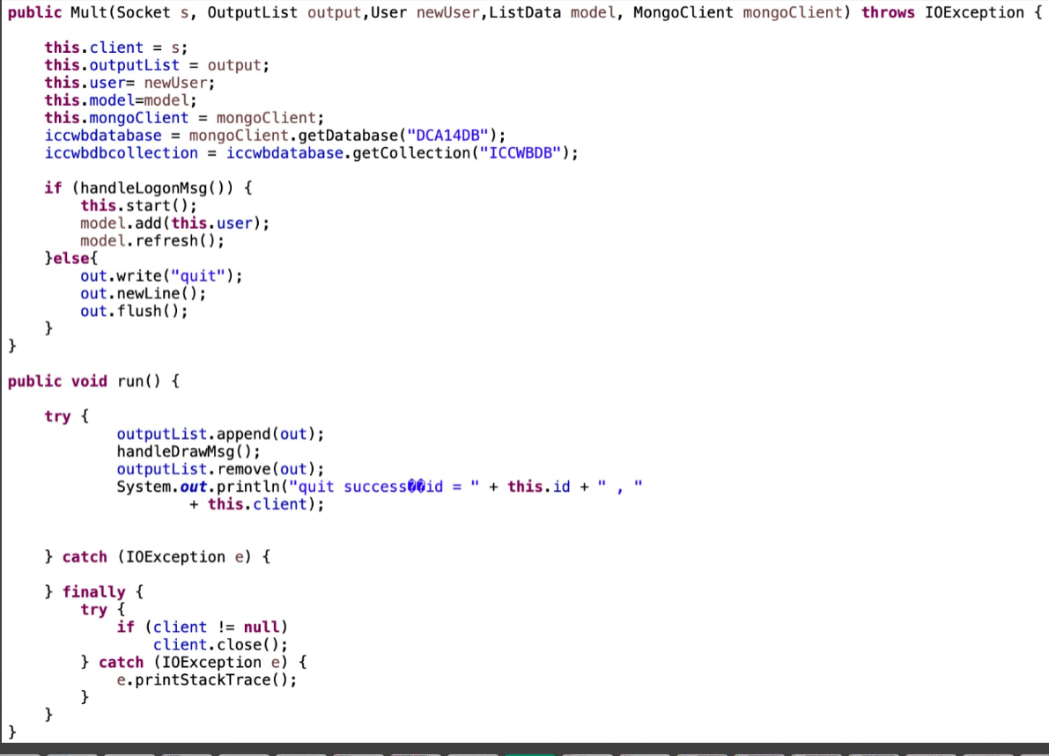
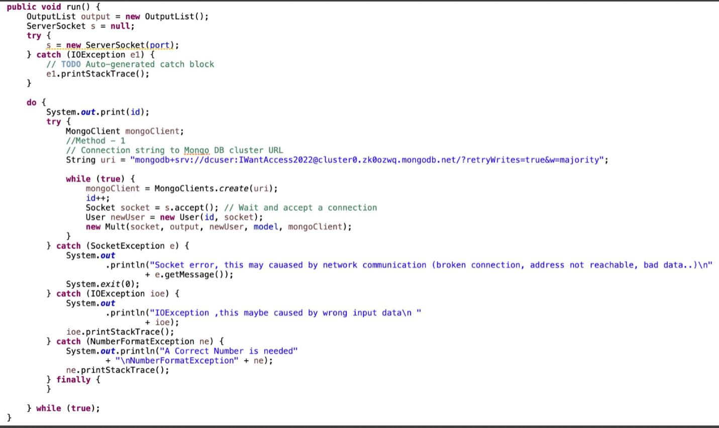
The below code is the server-side code required to be run on the server inside the EC2
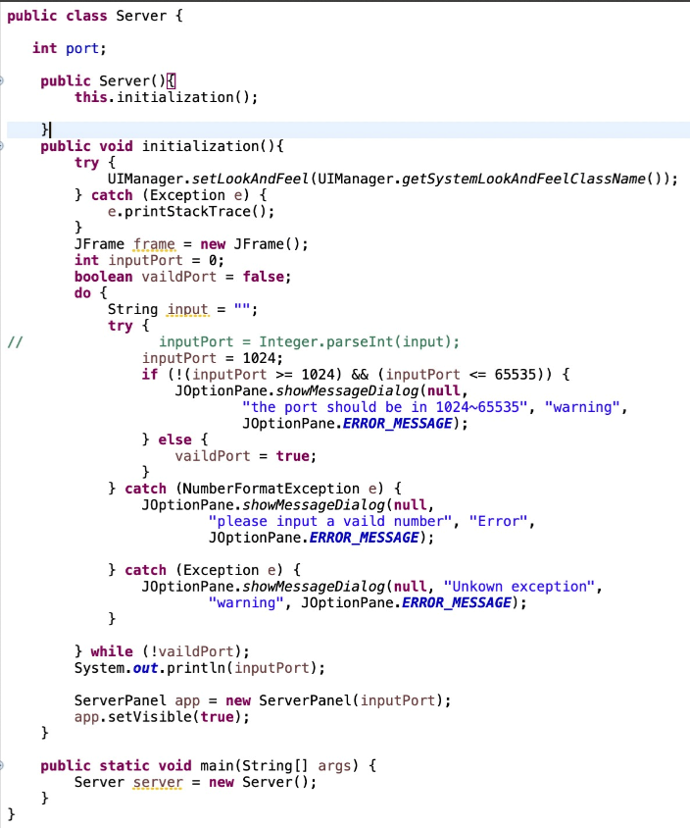
Whiteboard Application:
The difference in colors on each client is intentional to differentiate between the different clients.
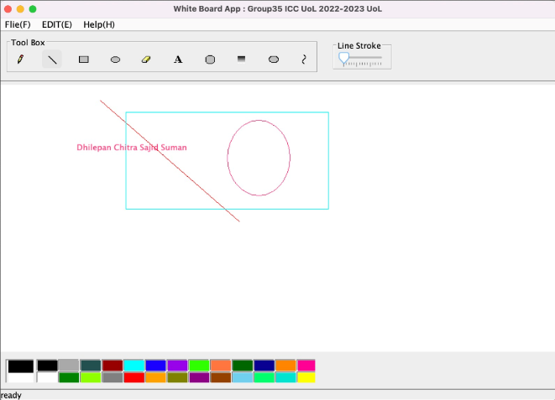
Client1:
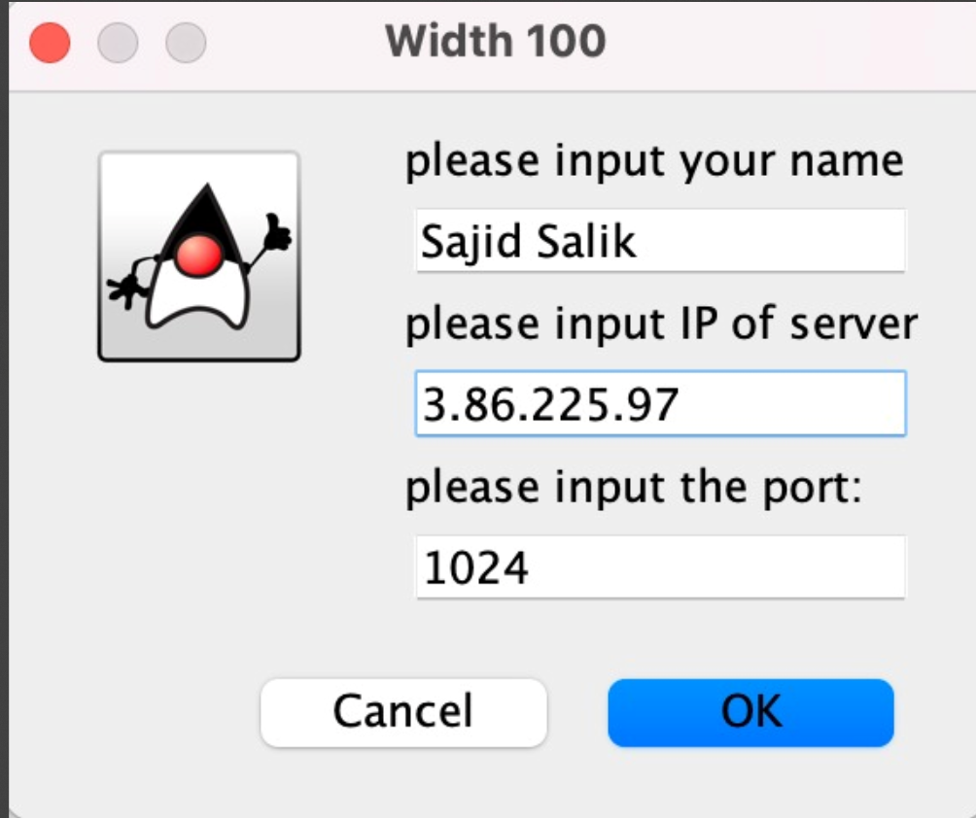
Client 2:
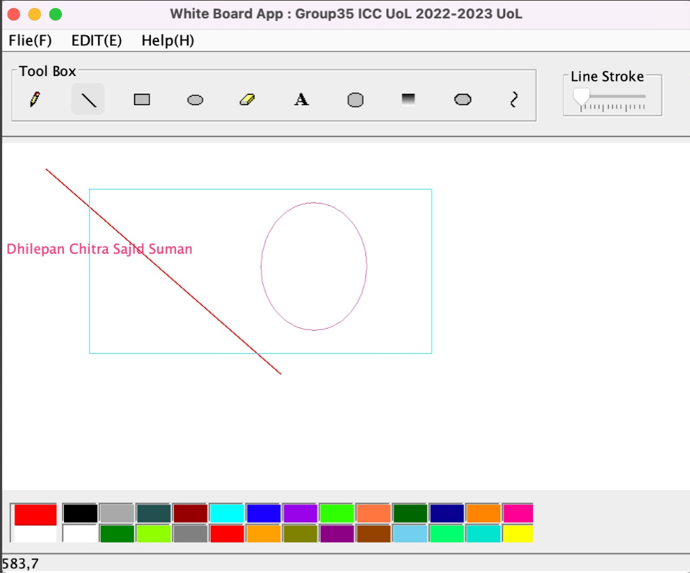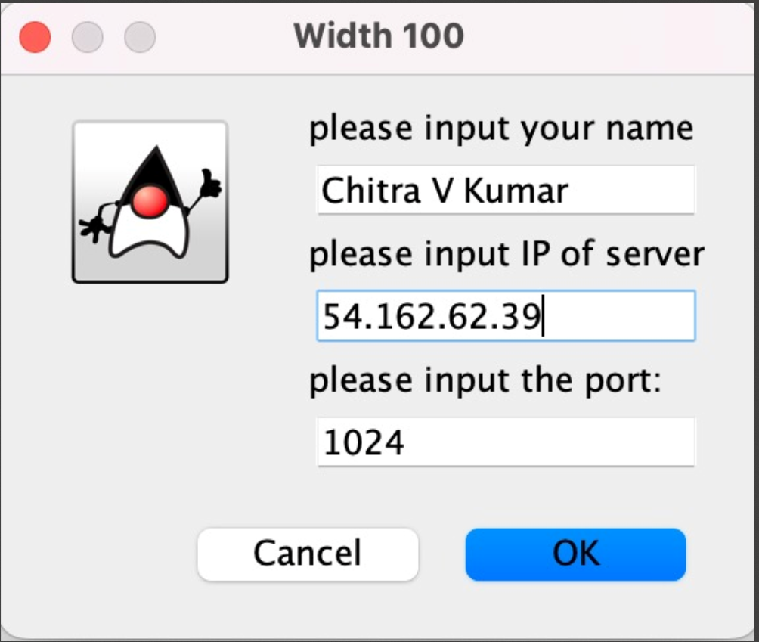

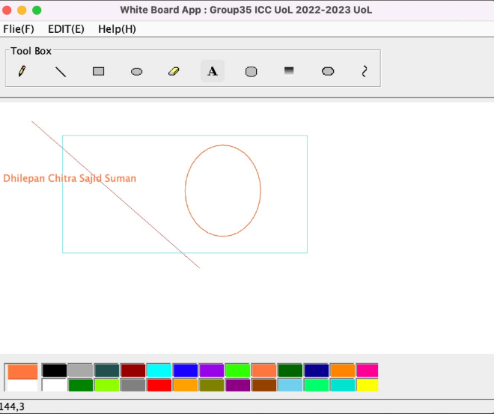
Client 3:
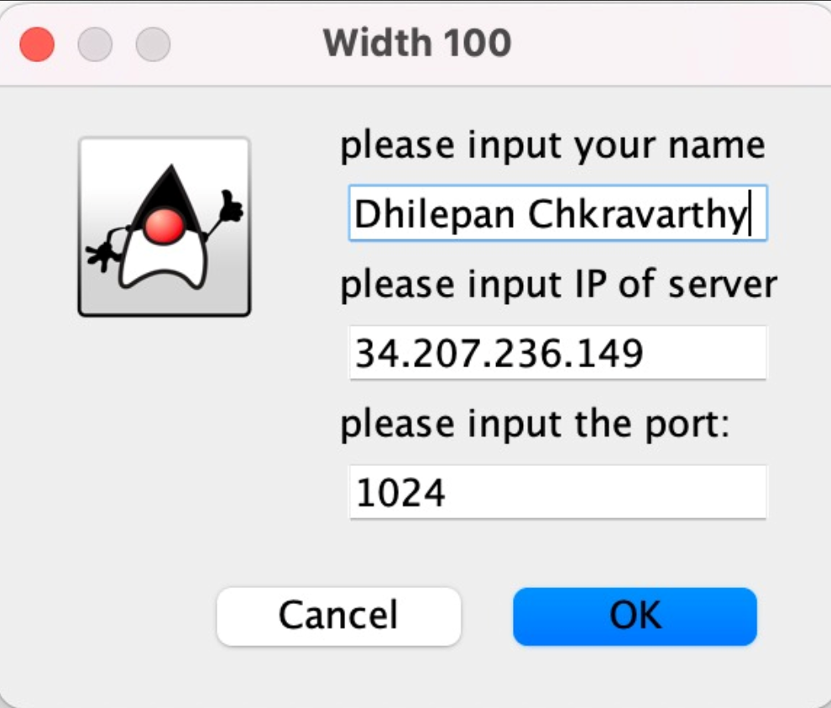

As seen above, each client connects to the white board application via the IP address of the server from the instance and the common port used here is 1024. All the clients are distributed on three separate machines with jar files of the client code installed on those machines.
Ref for Whiteboard Application: https://github.com/wybneu/WhiteBoard

Monitoring:
The AWS provides us the several services and tools to monitor our applications performance, the resources being used, collects logs and metrics.
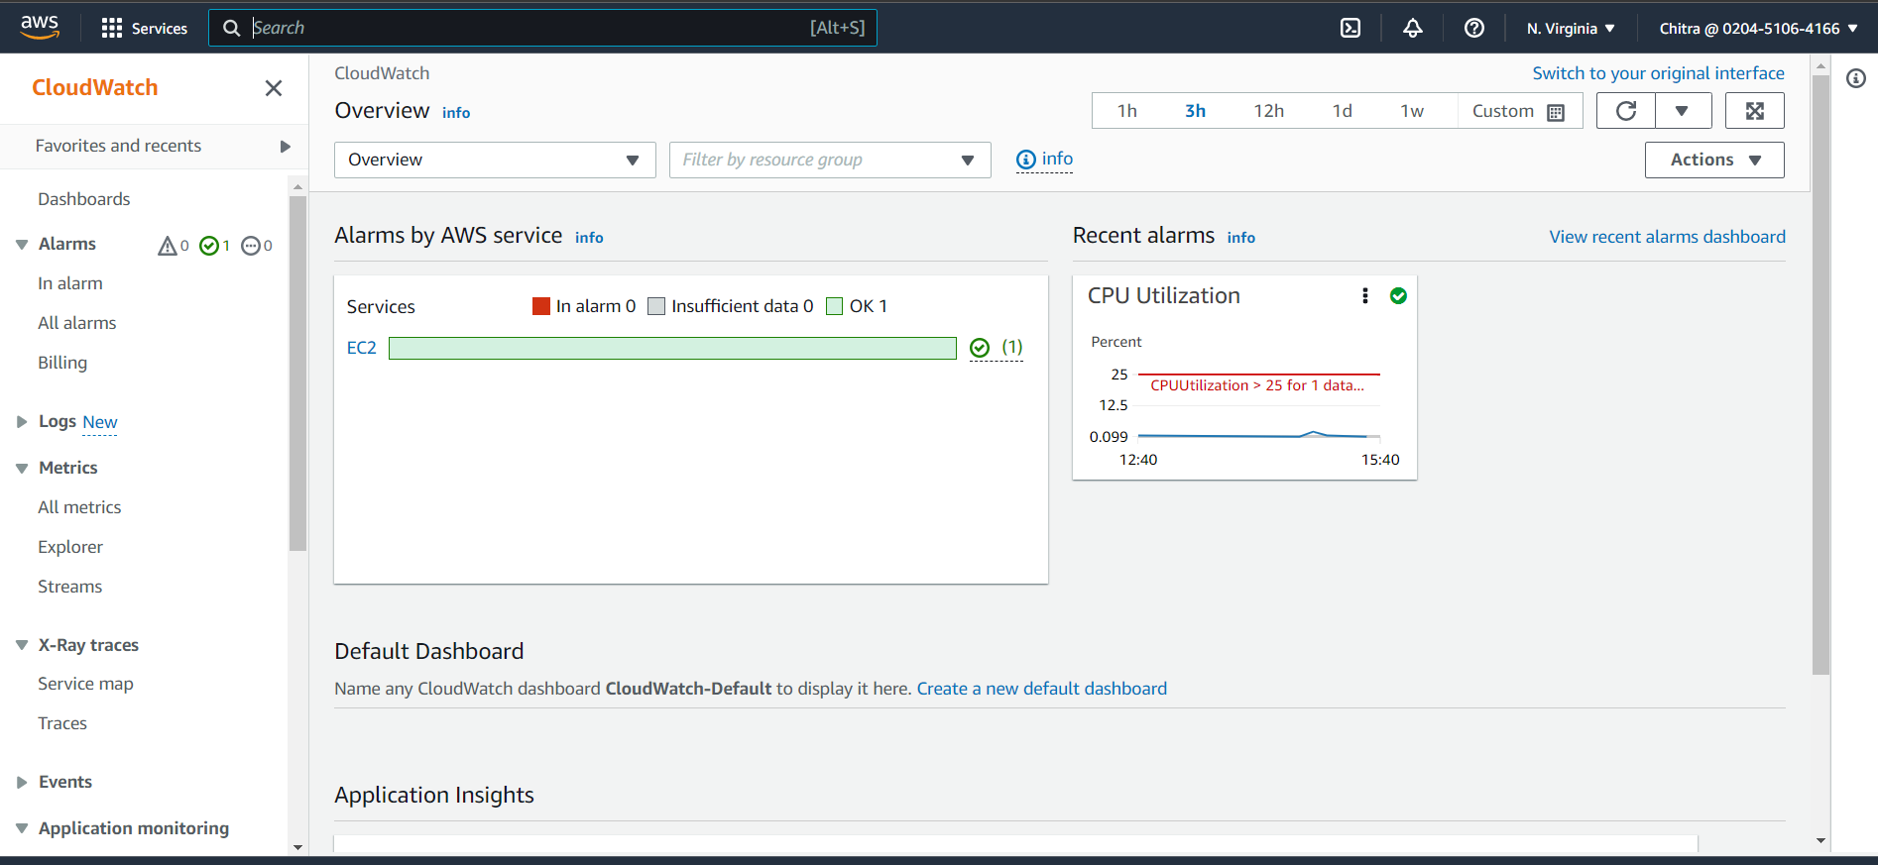

The AWS also provides tools to set up threshold for CPU utilization and set alarms whenever the threshold value crosses the limit alarm notifies through SMS, email etc.
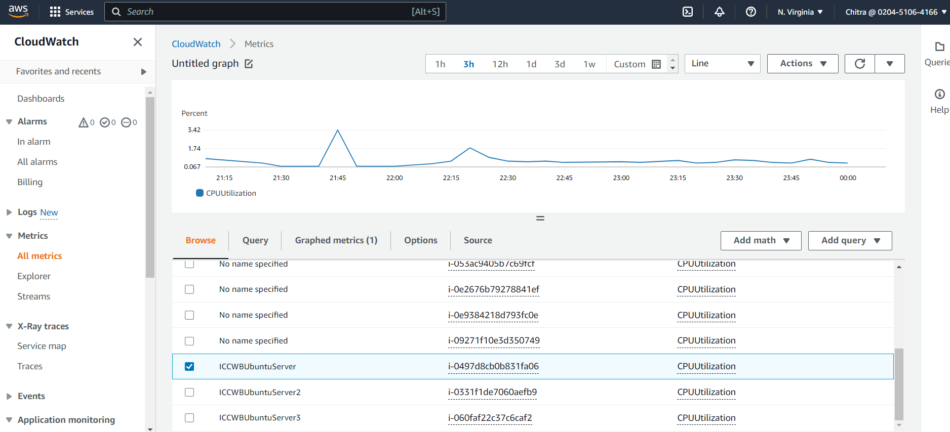

Cloud Watch also provides metrics on request sums for application Elastic load balancer which publishes data points for load balancers and our target.
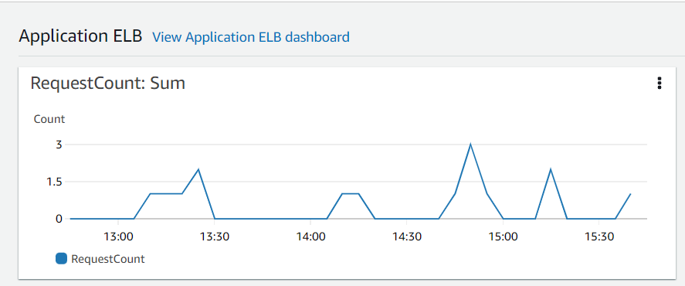
Task 4:
Individual Contribution:
I have designed the private cloud using an online diagram tool called the apps.diagrams.net
I have contributed to designing the whiteboard application and making necessary changes to it to suit the requirements of our project.
I have also hosted and deployed the application over the AWS cloud along with my teammates.

Task 5: Critical Review of our Design
Strengths of the proposed Design:
- The design offers good scalability in the form of performance by the load balancer to scale the nodes accordingly by managing its workload.
- By using a document-based database i.e., MongoDB there are no restrictions in the format of data storage.
- The Master slave approach is fast.
- Replication of data enables faster Read Writes requests.
- Customization of Virtual Private Cloud gives us the freedom to add the resources we need providing reliable and scalable environments.
- Lower risks of data breaches as private clouds provide multi-layer security.
- More efficiency is achieved as there is more control over infrastructure and data and changes can be made easily if necessary.
- According to the CAP theorem, our application is distributed with consistency and availability achieved. Not everything can be achieved.

Weakness of the proposed design:
- The cost of maintaining, monitoring, and running a private cloud is very expensive.
- Reliability is according to the resources at hand like CPU, RAM and other software and hardware requirements.
- Our design struggles with latency problems as the resources in the databases increase.

Suggestions to make our design better:
- The use of NAT Gateway for our private IP addresses will reduce the cost as we don’t have to buy new IP addresses for every instance, conserving IPv4 addresses provides access to privatization of IPs, flexibility with connection and consistency in the network.
- Implementation of Amazon EFS storage would give us the advantage to support any workloads. The servers and EC2 instances can access the shared file systems parallelly.
- Implementation of Amazon SQS service which provides asynchronous messaging between different software components.

